DEEP LEARNING INTEGRATED SMOKE AND FIRE SYSTEM FOR FORESTS

***Abstract-*** **Forests are a crucial resource that benefit people directly and indirectly in a variety of ways. Natural disasters like forest fires have a substantial impact on both global warming and the continuation of life on Earth. Therefore, in order to reduce the likelihood of tragedies, research on the automatic detection of forest fires is essential. Early detection of fire may be advantageous to decision-makers when developing extinguishing and mitigation strategies. This paper examines artificial intelligence-based computer vision techniques for smoke and fire detection in photographs. Artificial intelligence (AI) approaches like Convolution-Based Neural Networks(CNNS) have demonstrated beneficial performance than developments in methodology in computer vision applications like photo categorization. CNN training could also be extremely expensive.** **Additionally, a pre-trained CNN may perform poorly in scenarios when a sufficiently huge dataset is not available. The solution to this issue lies in testing transfer learning on trained models. When models are employed for learning transfer, they might not be able to categorize data from the original datasets. To tackle this challenge, we use learning without forgetting (LwF) to educate the network on a new task while keeping its prior knowledge.**

***Keywords: InceptionV3, CNN, Xception, Forest fire, Deep learning,***[***neural network***](https://www.mdpi.com/search?q=neural+network)***,Image processing,Vgg16,keras,*** ***image segmentation.***

# Introduction

The earth's ecosystem depends heavily on forest fires[1], which occur frequently. It happens all around the world, every month of the year. As such, it poses a severe risk to civilization, carries a high financial burden, and is a major factor in ecological shifts. Every year, 2.3% of the world's land area burns, which has a significant impact on ecosystems and human livelihoods. Each year, millions of hectares are lost due to forest fires, depleting the availability of oxygen, The earth's climate[2] is changing due in large part to the loss of these species and the increase in carbon dioxide.

Wildfires[3] pose a severe risk to human life, property, and ecosystems. Every year, they cause terrible damage in many places of the world, including Australia and the United States. Even with a great deal of study conducted on smoke and fire detection techniques, there is still much that can be done to enhance the precision, effectiveness, and versatility of current models. The broad deployment of fire detection systems is hampered by issues such high installation costs, storage needs, and false alarms[4]. Additionally, the unpredictable nature of wildfires makes precise identification difficult due to their variety of colors and shapes.

Moreover, the necessity for proactive fire management techniques is highlighted by the rising frequency and intensity of wildfires, which are being made worse by causes including climate change[5] and human activities.By adding cutting-edge deep learning algorithms to fire detection systems, we can improve our ability to locate, monitor[6], and put out wildfires, ultimately lessening their negative impact on habitats and populations.

The fact is widely understood that creating new deep learning algorithms is frequently complicated by the need for training data. Data is sometimes insufficient and frequently unavailable. For deep learning algorithms to be effective, enormous amounts of data are needed. Classification always benefits from more data. Although there are tools for collecting fire data, the datasets photographs aren't necessarily evenly distributed. To combat this, picture augmentation techniques can be used to synthesize samples from the source datasets . The findings indicate that local dataset creation could aid in enhancing classification accuracy. Early smoke detection[7] may also help to avoid a large-scale fire. For the purpose of preventing and detecting wildfires, this is a highly helpful application. The prediction and detection of forest fires is one use of machine learning techniques, such as CNNs.

Deep learning can automatically extract complicated feature representations from images, whereas machine learning[8] based techniques depend on human information extraction. Transfer learning provides a way to transfer knowledge between domains with less data by addressing the wide parameter space that deep architectures require.

Developments in deep learning[9], specifically with regard to convolution neural networks (DNNs) and Deep neural networks (CNNs), offer excellent opportunities for enhancing the efficiency of smoke and fire detection systems. Although CNNs have proven to be highly accurate in classifying images, their high processing and storage needs provide practical difficulties for use in real-world scenarios. SqueezeNet[10] and other lightweight designs are examples of recent advancements that provide more accurate alternatives while maintaining efficiency. Furthermore, early wildfire and smoke detection in susceptible areas can be enhanced by combining deep learning techniques.

By analyzing fire and smoke photos, video surveillance technology helps detect fires, but processing continuous image streams is a challenge. The development of computer vision-based smoke and fire detection technologies is made possible by improvements in machine vision-based image processing[11], which speed up transmission and sensing. These techniques use many color schemes, including YUV, CIELab, RGB, and YCbCr, to depict the characteristics of fire.

This paper main goal is to use deep learning techniques to create a reliable and accurate system for smoke and forest fire detection. The suggested system seeks to identify fire or smoke in almost real-time by evaluating photos taken from multiple sources, including drones, satellite photography, and surveillance cameras[12]. By being proactive, fire departments can respond quickly, possibly saving lives, property, and priceless natural resources. The integration of deep learning techniques, transfer learning approaches, and image processing Strategies will be examined to create a trustworthy and effective method for identifying forest fires and smoke. We hope that this study will develop preventative approaches to managing forest fires, thereby reducing the destructive effects that these events have on human communities and ecosystems.

# RELATED WORK

Prior research has investigated a variety of methods for detecting forest fires, from straightforward image processing procedures to intricate machine learning systems. CNNs, especially pre-trained models such as VGG16, have been used by certain researchers for image classification applications such as smoke and fire detection. When labeled data is scarce, transfer learning—which involves optimizing pre-trained models on certain datasets—has proven successful. Furthermore, methods like early halting have been used to enhance model generalization and avoid overfitting.

In one study, Dampage et al. [13] described a system and approach for earlier forest fire detection utilizing a wireless sensor network. Regression model based on machine learning was also suggested as a way to raise fire detection accuracy. For extended periods of time, the solution can operate independently since its main power source consists of rechargeable batteries that are supplemented by solar power.

  Raghad K. Mohammed et al. [14] provided a study on smoke and fire detection. They proposed extracting patterns reminiscent of smoke and forest fires using deep learning technology, or more accurately, transfer learning. Inceptionv3,ResNetv2, a pre-trained network, was employed in the research. The ImageNet dataset was used for training, and their dataset—which contained 1,101 images for each class of smoke and fire—was used for refinement. The model showed good classification performance with scores of 98.09%, 99%, 97.08%, 98.09%, and 97.40% for precision, accuracy, specificity, recall, and f1-score, respectively. For deployment and a Raspberry Pi gadget with a camera required to be integrated with the model.The authors processed the camera feed frame by frame using the OpenCV library and predict the likelihood of smoke or fire detection in constant time.

Zhixiang Liu and collaborators et. al. [15] offer a comprehensive examination of current advancements in uncontrolled aerial vehicle(UAV) systems-based forest fire monitoring, detection, and suppression. An overview of the development and system architecture of uncontrolled aerial vehicles (UAVs) used for tracking, identifying, and putting out forest fires opens the review. Next, a number of technologies related to the use of uncontrolled aerial vehicles (UAVs) in managing forest fires are discussed. These include cooperative UAV control, image stabilization techniques, and fire detection, diagnosis, and prognosis.

Junguo Zhang et al.[16] presented three approaches to the detection of forest fires. Initially, the Faster R-CNN framework was utilized as the fundamental architecture. Second, separable convolution was used to create a receptive field of integrated environmental information in a component perception module designed to improve recognition accuracy. Thirdly, to lessen the divergence brought on by rounding during the ROI pooling procedure, a ROI pooling with a multi-level structure was put in place. The results of the trial revealed an average identification speed of 1.5 ms per image, a 96.72% recognition accuracy rate, and an Intersection Over Union (IOU) of 78.96%. There was a 2.5 percent false-positive alarm rate, with a false-negative rate of 3.28%.

# METHODOLOGY

*Dataset description:*

The JPSS, SUOMI NPP, TerraSAR-X, and GOES geostationary weather satellites, among others, were utilized to produce the study's required dataset [17]. Notorious for their exceptional temporal precision and capacity to detect flames in remote areas, these satellites are used all over the world to detect fires.

worldwide.Satellite imagery has also been assembled, in addition to photos from kaggle and Google.

(<https://www.kaggle.com/kutaykutlu/forest-fire>)

The [fig1] below provides a visual representation of all the fire and smoke photos in the training dataset.

The [fig2] below provides a visual representation of all the smoke and fire photos in the validation dataset.

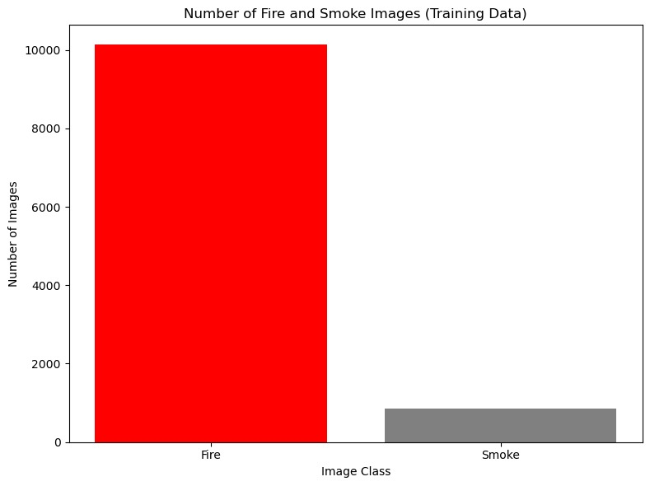

Fig1: Images of Fire and Smoke Distribution in Training Data

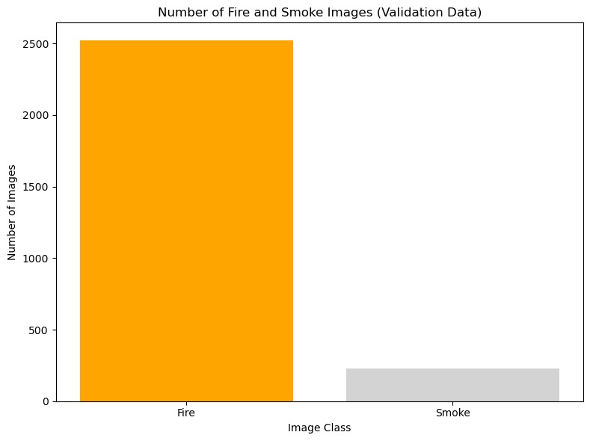Fig2:The distribution of images showing fire and smoke in the validation data

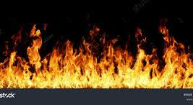 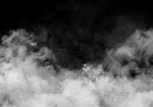

(a)Fire (b)Smoke

Fig3: Sample images from each class in dataset

The Above Fig3 shows the sample images present in the Dataset which belongs to each class

*Dataset collection and pre-processing:*

The Fire and Smoke Dataset[18], which has 13733 photos, was employed in this case.

The pre-processing steps listed below have been done to the raw Fire and Smoke Dataset.

1) Resizing: Pictures are scaled to a target size of (224, 224) pixels using the image_size parameter.

2) Normalization: Pixel values are typically normalized to between 0 and 1. Though not explicitly stated, the image_dataset_from_directory function usually performs this normalization as part of its processing.

3) Shuffling and Batching: The dataset is batched into smaller sets for effective training after being shuffled to remove any bias caused by the image order.

Following that, we used to separate the dataset into sections for training and validation in an 80:20 ratio and to resize, rotate, and alter the dimensions of the photos. 100% of the dataset was used for testing.

*CNN Variants:*

Despite being employed in image processing and classification, CNNs are also used as feature extractors and classifiers in uses of image enhancement. Existing network architectures such as Xception, Inception, and ResNet are investigating novel ways to generate convolutional layers to improve efficiency of learning rather than depending only on convolutional layers layered like those in LeNet and AlexNet,[19] and VGG. Despite being a standard CNN architecture, VGG is often employed due to its ease of use. In this work, we train the fire picture classification algorithms VGG16, InceptionV3, and Xception. The pre-trained models used in this investigation are covered in the section that follows.

*VGG16:*

The widely used VGG16 (Visual Geometry Group) CNN architecture is employed in the large-scale visual database project ImageNet. Due to its ease of implementation, VGG16 is commonly used in several deep learning image categorization techniques. Even though it was unveiled in 2014, it is still among the best vision architectures available. To reduce the linearity of the decision function, VGG employs 1×1 convolutional layers without changing the receptive fields. Since the convolution filters in VGG are small, it is possible to have a large number of weight layers; naturally, more layers equals better performance.

*Inception v3:*

This CNN architecture is a modification of the Inception family that includes batch normalization and smoothed labeling, among other modifications. InceptionV3 is primarily concerned with reducing processing power consumption by optimizing the earlier Inception architectures. It is discovered that Inception networks have higher computational efficiency when compared to VGGNet.[20] Inception networks use less resources and generate fewer parameters than its predecessors because of this efficiency. We applied dimension reduction, factorized convolutions, regularization, and parallel computations to InceptionV3 in order to enhance its project-related performance.

The procedure[fig4] for developing a deep learning model for smoke and detection of forest fires can be seen in the flowchart.diagram.   
 Creating a dataset of images with smoke and flames is the first step. Preprocessing, which includes resizing, scaling, and normalization, is then applied to this data collection. A testing set and a training set are then generated from the data.

Training with the training set is done on a machine learning model. This is followed by an evaluation of the model using the testing set.By comparing the model's output with a ground truth label which could be from manual observations the accuracy of the model is determined.

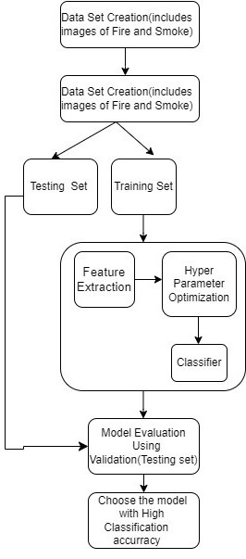

Fig4:WorkFlow Process

*Model Creation and Training:*

The model is created using methods based on deep neural networks. We created the model by starting with "vgg16" as the foundation model and adding four layers to it.

### vgg16: Convolutional neural networks like vgg16 are made for applications like object recognition and image classification. This increases the network's resilience to varying item sizes in the input photos by enabling it to record

features at several scales. Compared to conventional convolutions, vgg16 uses depth-wise separable convolutions, which need less calculations and parameters.

2) Flatten Layer: This layer creates a one-dimensional tensor from the multi-dimensional output tensor.

3) Dropout Layer: A part of the input units is randomly set to 0 by dropout during training. This aids in avoiding overfitting.

4) Dense Layer (activation= "sigmoid"): The last Dense layer with two units and sigmoid activation is added. The output probabilities for the two classes are generated by this layer (assuming a binary classification task).

Finally, we employed the well-known Adam optimization approach, which helps to achieve high accuracy by adjusting the learning rates of each parameter separately.

*Evaluation Metrics*:

Performance evaluation of DL models is based on common measures including F1-score, recall, accuracy, and precision. These metrics shed light on how well the model distinguishes between Fire and Smoke.

.   
Making a data set of pictures of smoke and fire is the initial stage. Next, this data collection undergoes preprocessing, which entails normalization, scaling, and resizing. Next, the data is used to produce a testing set and a training set.   
  
A machine learning algorithm is trained on the training set.

After that, the testing set is used to assess the model. By comparing the model's output with a ground truth label which could be from manual observations the accuracy of the model is determined

# IV..RESULTS AND DISCUSSION

*Confusion Matrix:* To evaluate the functionality of the model more thoroughly, a confusion matrix [Fig5] was made. The matrix revealed information about how well the model classified photos with smoke and fire. False positives and false negatives denoted incorrect classifications, but true positives showed photos that were accurately recognized as including smoke or fire. The confusion matrix analysis identified the model's strong points and regions in need of development.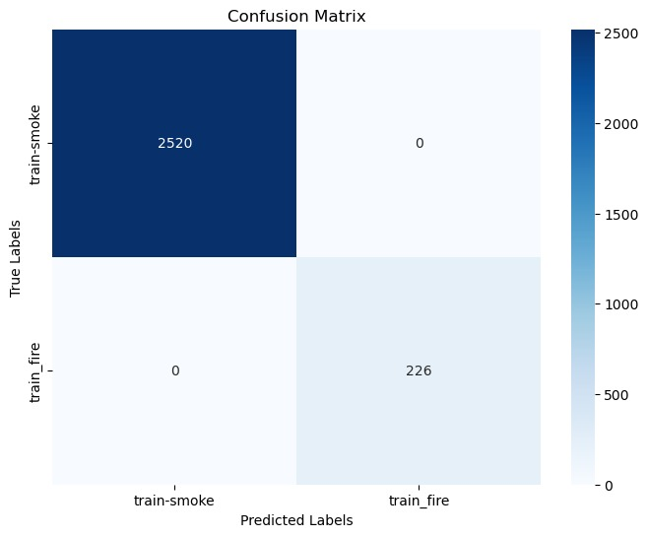

Fig5:Confusion Matrix

*Training and Model Architecture:*

A pre-trained VGG16 architecture, originally created for image classification tasks, was utilized by the forest fire and smoke detection model. The network learned to extract pertinent features from input images by honing the pre-trained model on the dataset. This made it possible for it to distinguish between pictures that had smoke and fire and ones that didn't. Furthermore, a 20% dropout rate dropout layer was included to help prevent overfitting during training.

*Training Process:*

When training the model, the binary cross-entropy loss function and the Adam optimizer were used. Just 20% of the dataset was used for training; the remaining 80% was used for validation.

Early stopping was implemented throughout three patient epochs to prevent overfitting and ensure that the model functions well when applied with newly collected data.

*Measures of Performance:*

The model showed encouraging results on both the training and validation sets after five epochs of training. The percentage of correctly identified images was represented by the accuracy metric, while the difference between the anticipated and actual labels was measured by the loss meter. On the validation set, the model performed admirably.

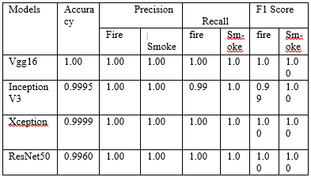

Tabe1:Performance Metrics on DL Models

Four models[Table1] are used evaluated in the paper. In the 4 models which is implemented Vgg16[21] has given the best performance. outcomes were assessed using the f1-score, accuracy, recall, and precision metrics. Table. II shows a comparison of different models using the previously listed performance measurement variables. Our results show notable gains in performance and accuracy for Forest Fire and Smoke Detection[22] when compared to baseline methods. Vgg16 achieved a high accuracy of 99% with strong performance in terms of Recall, f1-score, and precision metrics.

# Conclusion

Early and accurate detection of active fires is essential to reducing the devastating effects of wildfires. There are very few studies that use deep learning techniques to monitor ongoing fames in almost real-time. In this study, we looked into how pre-trained models for smoke and forest fire detection could learn from each other. We extracted and refined characteristics using the models. The vgg16-based model performed better than all other models, according to the results, with 99.0% accuracy. We used LwF to maintain the properties of the old dataset and discovered that it works better than feature extraction.

The most fascinating element is that using LwF to fine-tune the new task functioned reasonably well on the original dataset when the parameters were tuned.

According to recent studies, it's imperative to promptly and precisely identify fire incidents in their early phases in order to stop them from spreading. We wish to expand on and improve our findings from this research as a result. We intend to use the most recent CNN models in the future to quickly and accurately detect fire incidents with a low false positive rate.

##### References

[1] Barmpoutis, Panagiotis, et al. "A review on early forest fire detection systems using optical remote sensing." Sensors 20.22 ,pp. 6442. (2020):

[2] Sherwood, Steven C., et al. "An assessment of Earth's climate sensitivity using multiple lines of evidence." Reviews of Geophysics 58.4 (2020):

[3] Pausas, Juli G., and Jon E. Keeley."Wildfires and global change." Frontiers in Ecology and the Environment 19.7,pp. 387-395. (2021)

[4] Jung, Yungbum, et al. "Taming false alarms from a domain-unaware C analyzer by a bayesian statistical post analysis." International Static Analysis Symposium. Berlin, Heidelberg: Springer Berlin Heidelberg, 2005.

[5] Wheeler, Tim, and Joachim Von Braun. "Climate change impacts on global food security." Science 341.6145 (2013): 508-513.

[6] Uitto, Juha I. "Multi-country cooperation around shared waters: role of monitoring and evaluation." Global environmental change 14 (2004): 5-14.

[7] Kim, DongKeun, and Yuan-Fang Wang. "Smoke detection in video." 2009 WRI World Congress on Computer Science and Information Engineering. Vol. 5. IEEE, 2009.

[8] Gollapudi, Sunila. Practical machine learning. Packt Publishing Ltd, (2016).

[9] Bengio, Yoshua, Ian Goodfellow, and Aaron Courville. Deep learning. Vol. 1. Cambridge, MA, USA: MIT press, (2017).

[10] Hu, Jie, Li Shen, and Gang Sun. "Squeeze-and-excitation networks." Proceedings of the IEEE conference on computer vision and pattern recognition.( 2018).

[11] Manish, R., Adigopula Venkatesh, and S. Denis Ashok. "Machine vision based image processing techniques for surface finish and defect inspection in a grinding process." Materials Today: Proceedings 5.5 pp. 12792-12802 (2018).

[12] Sheng, Hao, Keniel Yao, and Sharad Goel. "Surveilling surveillance: Estimating the prevalence of surveillance cameras with street view data." Proceedings of the 2021 AAAI/ACM Conference on AI, Ethics, and Society. 2021.

[13] Dampage, U., Bandaranayake, L., Wanasinghe, R. et al. Forest fire detection system using wireless sensor networks and machine learning. Sci Rep 12, 46 (2022).

[https://doi.org/10.1038/s41598-021-03882-9](https://doi.org/10.1038/s41598-021-03882-9%20)

[14] Raghad K. Mohammed A real-time forest fire and smoke detection system using deep learning(2022)

<https://doi.org/10.22075/ijnaa.2022.5899>

[15] Chi Yuan, Youmin Zhang, and Zhixiang Liu. “A survey on technologies for automatic forest fire monitoring, detection, and fighting using unmanned aerial vehicles and remote sensing techniques,”(2021)

[16] Zhao, E.; Liu, Y.; Zhang, J.; Tian, Y. Forest Fire Smoke Recognition Based on Anchor Box Adaptive Generation Method. Electronics 2021, 10,566. [https://doi.org/10.3390/electronics10050566](https://doi.org/10.3390/electronics10050566%20)

[17] Kaulage, A., S. Rane, and S. Dhore. “Satellite Imagery-Based wildfre detection using deep learning: ‘Data Science’,”pp. 213–220. (2022).

[18]kaggledataset,<https://www.kaggle.com/kutaykutlu/forest-fire>

[19] Iandola, Forrest N., et al. "SqueezeNet: AlexNet-level accuracy with 50x fewer parameters and< 0.5 MB model size." arXiv preprint arXiv:1602.07360 (2016).

[20] Majib, Mohammad Shahjahan, et al. "Vgg-scnet: A vgg net-based deep learning framework for brain tumor detection on mri images." IEEE Access 9,pp. 116942-116952 (2021)

[21] Yang, Haoyan, et al. "A novel method for peanut variety identification and classification by Improved VGG16." Scientific Reports11.1 ,pp.15756(2021)

[22] Calderara, Simone, Paolo Piccinini, and Rita Cucchiara. "Vision based smoke detection system using image energy and color information." Machine Vision and Applications 22,pp. 705-719. (2011)